Manual
for installation of GerardFixed Font
in

[please do not edit]



Contents
<===============>
PG3: Full Installation Process
PG11: License agreement & readme.md file

[TO TAKE NOTE:]
[Page numbers are not shown]

Full Installation


1. Open your browser

2. go to https://github.com/GerardProductionsCorporation/GerardFixed-Font-For-Linux
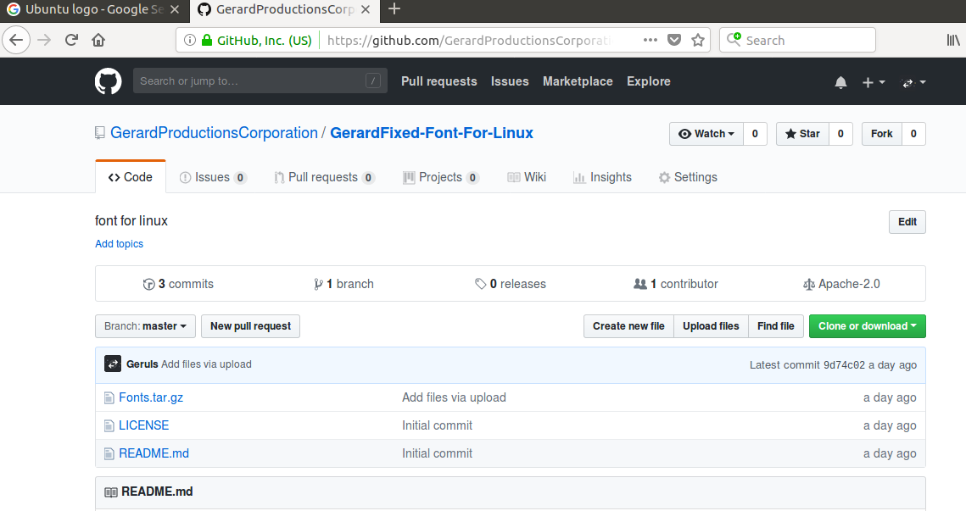

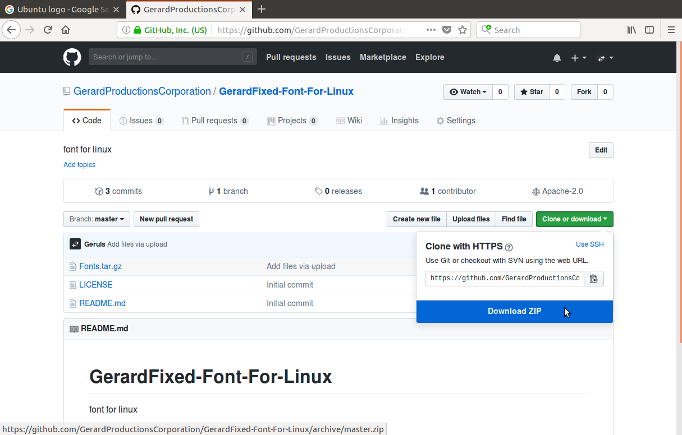
3. Click Clone or Download and then click Download ZIP

4. You will get this window. Select Open with Archive Manager and then click OK.
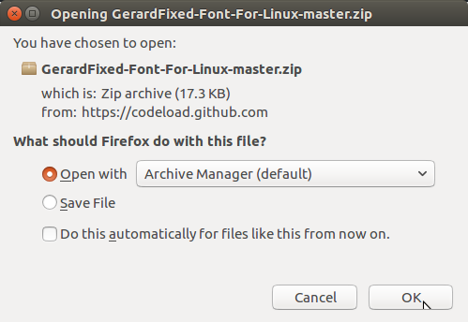

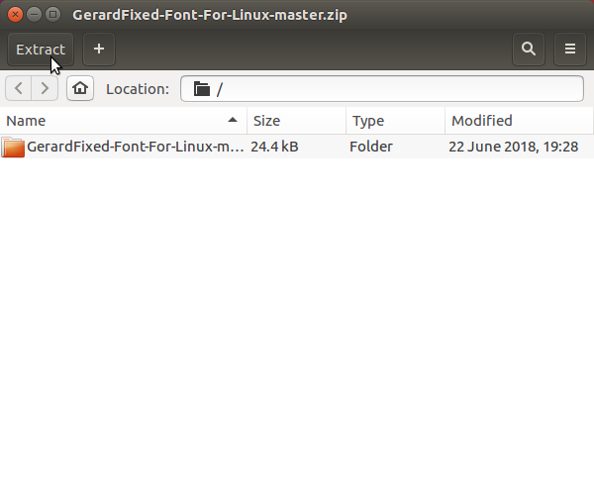
5. Click Extract

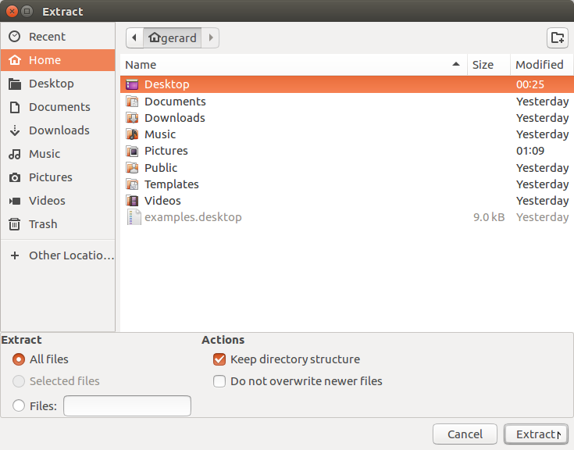
6. Select a place to extract all files and before extracting, click extract all files then click Extract.

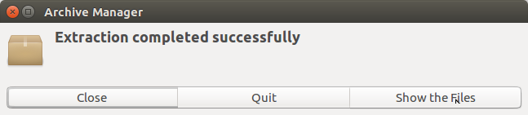
7. Archive Manager will show this window. Click Show the files.

8. Open the folder named ‘Gerard-Font-For-Linux-master’ then open Fonts.tar.gz.
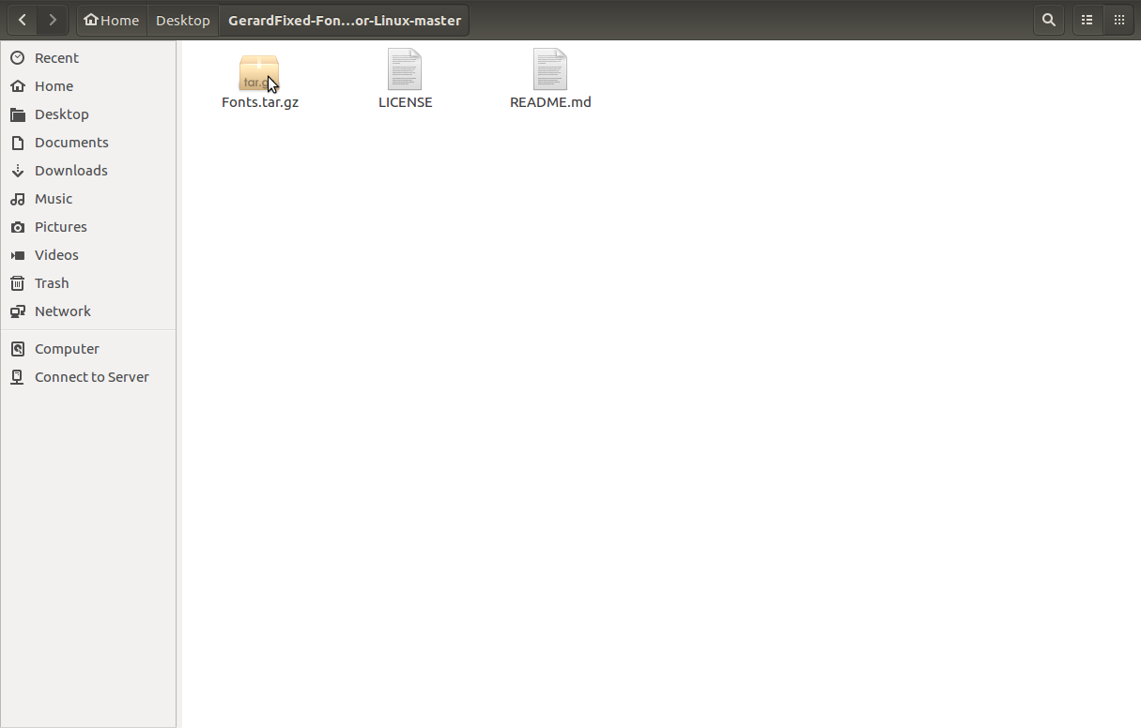
9. Click Extract.
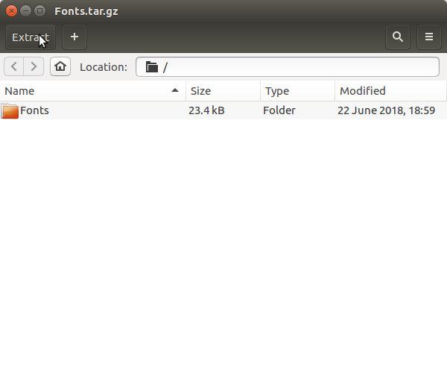

10. Choose a place to extract the .tar.gz file to. Before extracting, select: All files then click Extract.

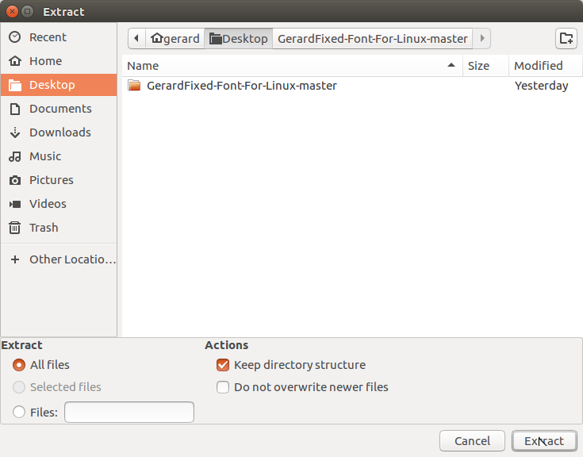

12. Click Show the files
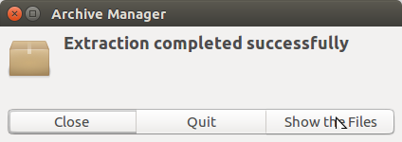

13. Open Fonts.
14. Open GerardFixed-Regular
15. Click install.
16. Open GerardFixed (1)
17. Click install.

You’re done!
Please read the next page.

LICENSE & README.MD FILE

END OF MANUAL
ISSUES? SCAN THIS QR CODE
<<<<<<<<<<=====>>>>>>>>>>



END OF MANUAL END OF MANUAL

